Statistical Evaluation of Protein and Sugar Nutritional Values

A hypothesis testing activity submitted by

Rex Orly Mallorca
T09-A

Engr. Gyro A. Madrona
Instructor

Computer Engineering Technology
TECHNOLOGICAL UNIVERSITY OF THE PHILIPPINES VISAYAS
February 2026

1. About the Dataset
The dataset used in this analysis contains nutritional values of protein and sugar, measured in grams (g). Each record represents the amount of protein and sugar associated with a specific calorie classification.
Source: https://www.kaggle.com/datasets/amineipad/food-nutrition-dataset-for-calorie-classification
2. Statistical Question
Is the nutritional value of protein significantly higher than that of sugar?

3. Hypotheses
$$H₀: μProtein ≤ μSugar$$
$$Hₐ: μProtein > μSugar$$
4. Test Statistic
4.1 Summary of statistics
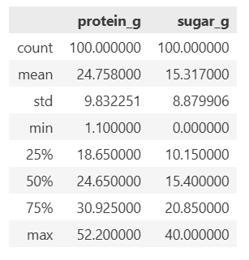
4.2 Boxplot
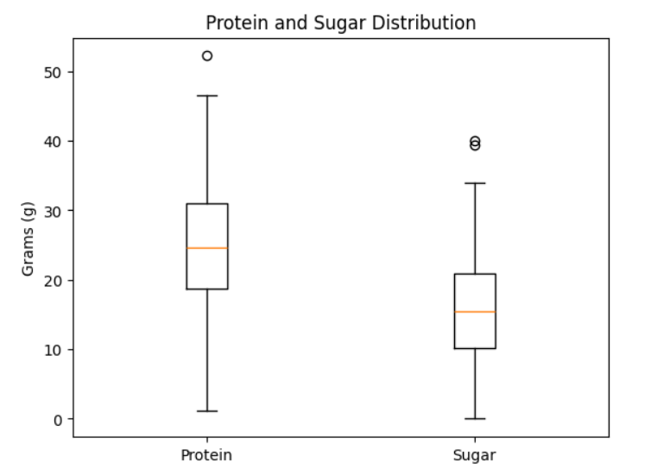

4.3 Normality Test
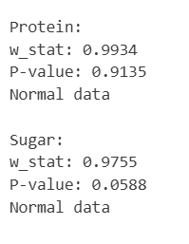
4.4 F-Test
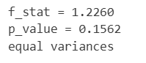
4.5 2-Sample t-Test
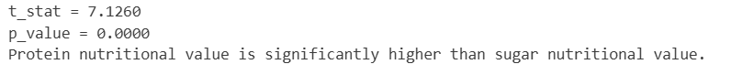
4.6 Power of the Test


5. Conclusion
Using a two-sample t-test to evaluate whether protein nutritional values are greater than sugar nutritional values, the analysis yielded a t-statistic of 51.9760 with a p-value < 0.0000. At the 0.05 significance level, the null hypothesis is rejected. This result indicates that the mean protein value is significantly higher than the mean sugar value in the dataset.

